Sender’s Name & Address ..............................................................

..............................................................

..............................................................

Post Code ...............................................
Mr Stephen Hamilton,
Principal Planning Officer
Strategic Planning Division
Millennium House
17-25 Great Victoria Street
Belfast BT2 7BN

Application ref: E/2013/0093/F for temporary works of drilling exploratory borehole to approximately 2700m depth to investigate underground strata for hydrocarbon exploration under DETI license PL3/10

Dear Mr Hamilton,

I wish to object to planning permission being granted for this application on the following grounds:
Contents
1. Insufficient, incomplete, and possibly misleading, information provided with the application 1
2. Risks to air quality, water quality and soil quality 7
3. Risks to public health 9
4. Risks to wildlife and environment 12
5. Risks to landscape and roads 14
6. Risks to valuable local industries of agriculture and tourism 15

Insufficient, incomplete, and possibly misleading, information provided with the application

The Rathlin Energy Ltd planning application (E/2013/0093/F) to drill a second exploratory well at Ballinlea does not clearly set out the detail of what the company is proposing to do, operationally, on the site. There is no clear description of the project from start to finish, outlining exactly what each stage would involve.

- Can a detailed description of the proposed development and operation, with stages from start to finish, be supplied by the company?
Some of the information which is provided is confusing and contradictory – particularly when set in the context of information provided at information sessions held for local residents on the 27th and 28th June.

Lack of clarity about the chemicals to be used in the drilling process

Rathlin Energy Ltd admitted, when questioned at their information session on 28th June in the Ballinlea Orange Hall, that they did not (at that time) know which chemicals which would be used in their drilling process—because the combination of ingredients to be used in the drilling mud would be decided by the drilling company or drilling design company engaged by Rathlin Energy to undertake that part of the project. (Rathlin Energy then provided to residents a list of the chemicals used in the drilling of Ballinlea 1 in 2008 (See Appendix 1), as an example of what could be used in Ballinlea 2.)

- Can Rathlin Energy be asked to provide a list of the chemicals they actually intend to use in Ballinlea 2 (with quantities)?
Despite the company’s admission that they did not know exactly which chemicals would be used in the drilling, they completed a number of questions on the planning application form (P1) about the nature of the chemicals they would be using or storing on site.

The company stated on their planning application form P1 that the development does not involve the use or storage of Liquid Petroleum Gas or other Hazardous Substances (Listed on a Form PA1).
However, Form PA1 includes “Gas or any mixture of gases which are flammable in air and is held in the installation as a gas”. And, the Hydrogeological Risk Assessment, which provides some insight into the planned operation, states that gas will be flared and cold vented on site, as well as separated from an oil and water mixture, and collected (stored) in tanks before removal from site (see below).

Form P1 – Application for permission to develop land (completed by Rathlin Energy Ltd/RPS):
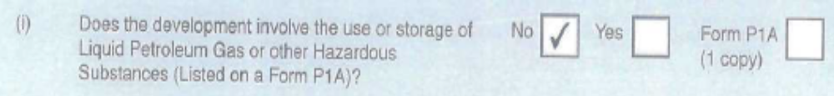

Form P1A includes:
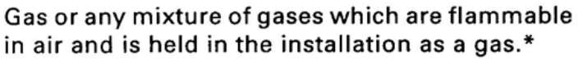

Excerpt from the Hydrogeological Risk Assessment supporting the application:
“Testing. It is planned to undertake evaluative drill stem tests and extended well tests. The extended well test could be for a period of up to 90 days when the petroleum reservoir is evaluated. During this period the well is pumped and is anticipated to produce a mixture of gas, oil and water. The gas will be flare or cold vented via temporary pipe work, and the oil and gas will be separated and collected in separate tanks before removal from site for disposal or further processing. The water will be saline and will be disposed of at an appropriate licensed waste facility. While on site the oil and water represent a potential source of contamination and will be held within tanks in bunded areas.”

- Should Rathlin Energy have ticked ‘Yes’ to question (i) on Form P1 and completed the associated paperwork?

Information provided to residents (upon request) after the information sessions revealed that some of the chemicals that would be used are toxic—e.g. the safety-sheet for ‘Safe-cide’ states that it is acutely toxic to humans (fatal if inhaled) and that the material and its containers are to be disposed of as a hazardous waste. Toxic materials are subject to the controls set out in the Planning (COMAH) Regulations (N.I.) 2000.
However, on their application form (P1) Rathlin Energy Ltd have stated that the proposal will not involve the use or storage of Hazardous Substances, which are subject to the controls set out in the Planning (COMAH) Regulations (N.I.) 2000.
Rathlin Energy’s P1 application form also stated that there is expected to be 300m³ (estimate) of drilling mud to be disposed of. This mud would include a cocktail of chemicals including toxic and hazardous substances (e.g. Safe-cide), hydrocarbons, heavy metals, and naturally occurring radioactive materials.
Form P1 – Application for permission to develop land (completed by Rathlin Energy Ltd/RPS):
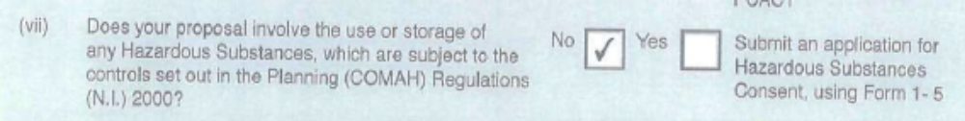

- ‘Safe-cide’ states that it is acutely toxic to humans (fatal if inhaled) and that the material and its containers are to be disposed of as hazardous waste.

- ‘Toxic’ materials are subject to the controls set out in the Planning (COMAH) Regulations (N.I.) 2000.

Form P1 – Application for permission to develop land (completed by Rathlin Energy Ltd/RPS):
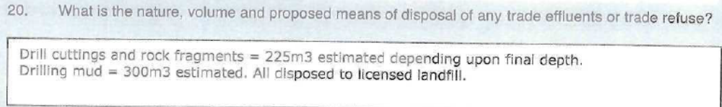

- Should Rathlin Energy have ticked ‘Yes’ to question (vii) on Form P1 and completed the associated paperwork?
- Were the individual quantities to be used not large enough to require identification?
- Would the combined effect of the range of toxins to be found in the large quantity of drilling mud warrant identification and control?
- Would the drilling mud be considered toxic or hazardous?
- How would Rathlin Energy and/or the relevant authorities in Northern Ireland ensure that the drilling mud does not prove to be a risk to human, animal or environmental health either during use or afterwards (i.e. the portion left in the ground after the operation)?
- Where exactly would the waste drilling cuttings, rock fragments and drilling mud from Ballinlea 2 be disposed of, and how would it be ensured that they are not posing a threat to human, animal or environmental health into the future?
- Where exactly were the waste drilling cuttings, rock fragments and drilling mud from Ballinlea 1 disposed of, and how is it ensured that they are not posing a threat to human, animal or environmental health into the future?
Another oil/gas company, Cuadrilla, planning to drill an exploratory well in Balcombe, Sussex, apparently require a mining waste permit and radioactive substance regulation environmental permit for their proposed development.

- Given the type of operation the Rathlin Energy proposal covers, which is similar to Cuadrilla’s, would it not also require a mining waste permit and radioactive substance regulation environmental permit, or other similar permits?
- What permits do Rathlin Energy require in order to undertake their proposed development, other than planning approval?
- Can Rathlin Energy Ltd be required or asked to produce a Site Waste Management Plan?

Inadequate external assessments supporting the application

A number of inadequacies (outlined below) have been identified in relation to some of the external assessments supporting the Rathlin Energy application. These inadequacies in turn raise questions about the suitability of the assessors to fully assess the potential impact of developments of this nature—associated with the oil and gas exploration and drilling industry.

- At least two of the external assessments provided by Rathlin Energy Ltd, to support their application, were conducted without the assessor having all of the information necessary to undertake a full and comprehensive assessment. The Extended Phase 1 Survey and Assessment and the Ornithological Surveys and Assessment reports to RPS June 2013, prepared by Kerry Leonard of Sterna Environmental, state the following constraint:

“A full outline of the proposed scope and scale of the development is not yet available. […] It has been assumed that the entirety of each site may be developed and there is potentially complete loss of derelict buildings, surrounding hedging, and all lands within the red line boundary defined for this survey.”(In “Constraints” section)

- The Air Quality Impact Assessment is significantly inadequate:
Three categories of potential impacts on air quality were set out in the Air Quality Impact Assessment:
- Traffic derived atmospheric pollution
- Operational engine derived atmospheric pollution, and
- Dust

  - It fails to mention that the operations at the site would include gas being cold vented and flared (burnt off) at the site (referred to in the Hydrogeological Risk Assessment)—it therefore fails to describe or assess the potential impact of cold venting and flaring on air quality. This is a significant oversight.

  - It fails to adequately describe or assess the potential impact of ‘atmospheric releases associated with oil exploration’—briefly mentioned in section 7.2 of the report (Operational engine derived atmospheric pollution, which is described as ‘similar to a diesel engine’).

Atmospheric releases associated with oil exploration:
- Include (but are not limited to) methane, volatile organic compounds, hydrogen sulphide, and BTEX (benzene, toluene, ethylbenzene and xylenes).
- are not engine-derived atmospheric pollution, and
- ought to be given considerable, dedicated, attention in an assessment of the air quality impacts of an exploratory oil/gas well development.

  - Because it fails to adequately describe or assess the potential impacts of venting, flaring or ‘atmospheric releases associated with oil exploration’, it also then fails to contain adequate monitoring or mitigation measures. The measures outlined in the report related almost exclusively to the control of dust, as related to construction and demolition projects, and the risk assessment and standards provided relate to dust control. The only reference to mitigation of atmospheric releases was that ‘monitoring in the form of diffusion tubes may be conducted, if required, in order to give confidence to Moyle District Council’. This does little to reassure local residents that the quality of their air, in terms of toxic pollutants, will be adequately managed.

- Did the air quality impact assessor not have access to all of the information necessary to prepare a comprehensive assessment (as indeed was stated by the Extended Phase and Ornithological Assessment authors)?
- How will the DOE ensure that all of the potential impacts of this oil and gas exploratory drilling development, on human, animal and environmental health, are adequately assessed, and taken into account in the decision-making about this planning application?

- The Extended Phase 1 Survey and Assessment and the Ornithological Surveys and Assessment were significantly inadequate:

  - Conclusions of ‘negligible’ impact on wildlife are reached without taking into account the impact of the following on the short or long term health of the wildlife at the site and in the surrounding area:
- the full scope and scale of the drilling activities which will be conducted on site
- the ‘atmospheric releases associated with oil exploration’ (referred to, but not adequately assessed, in the Air Quality Impact Assessment, Section 5.2),
- cold venting and flaring (burning off) of gases (referred to in the Hydrogeological Risk Assessment, but not mentioned or assessed for potential impact in the Air Quality Impact Assessment)
- potential leaks or spills into soil or waterways (considering industry figures that the first-year failure rate for wells is 6/7%, and the 15-year to 50-year failure rate can be as high as 50-60% (depending on source) ).

  - The Extended Phase 1 Survey and Assessment of Ballinlea report to RPS June 2013, prepared by Kerry Leonard of Sterna Environmental, does not include a data search from recognised biodiversity databanks including CEDAR and the National Biodiversity Network. This should have been included as part of the Phase I survey in order to create a more complete picture of the species present in the local area, both at the time of survey, in previous years and during other important nesting, feeding, wintering and roosting periods. Details of a data search were not included in the Phase I survey report and therefore this cannot be described as an ‘extended’ survey.

  - The Extended Phase 1 Survey and Assessment of Ballinlea also failed to assess the presence of bat species. Common Pipistrelles were recorded by an experienced bat surveyor at the derelict buildings sited in the north east section of the proposed drilling site at 49 Ballinlea Road on 12-06-2013 and 12-07-2013. A fully comprehensive survey of this site for bat species over a 12 month period was not completed as part of the Extended Phase 1 Survey and Assessment supporting Rathlin Energy Ltd’s planning application—the survey dates cited are 8 May and 03 June 2013.

It is vital that the site is monitored for bat hibernation roosts in January/February and a field survey also completed in April to August to fully understand the use of the site by these protected species.

- How will the DOE ensure that the use of the proposed Ballinlea site by protected bat species is fully understood and that the potential impact of the proposed development on them is taken into account in the decision making about this planning application?

  - The drawings of the sites are not adequately detailed and are causing confusion—these assessments include two sites, ‘1’ and ‘2’, raising questions about whether they include the original Ballinlea 1 well site and the proposed Ballinlea 2 site, or some other proposed sites.

  - Lack of recommendation for more detailed surveys for protected species: Comprehensive habitat and species surveys are required (and an industry standard) when protected species are found on any development site. The Northern Ireland Environment Agency requires that all biodiversity surveys are carried out to the Chartered Institute of Ecology and Environmental Management guidelines and these include a requirement for comprehensive surveys where protected species have been identified. Bats are known to use the area of potential development therefore an in depth survey for bats / bat potential, badgers, lizards, otters and newts should have been recommended in the Extended Phase 1 Survey and Assessment of Ballinlea. This was not done.

  - Lack of ‘Statement of Authority’ for Habitat Surveys: The Extended Phase 1 Survey and Assessment produced as part of the Planning Application does not include a 'statement of authority' i.e. an outline of the surveyors and authors involved and their qualifications and experience. This is standard practice for consultants’ reports but this has been ignored in Rathlin Energy’s Planning Application submission.

Further comment on the presence of flora and fauna at the site and in the surrounding area is provided in more detail in the ‘Risks to wildlife and environment’ section of this submission below.

- How will the DOE ensure that a more thorough assessment of the biodiversity on the proposed site is conducted?

Risks to air quality, water quality and soil quality

Well failure

As mentioned previously, the rate of drilled wells that fail (leak/blow-out) is reported by the oil and gas industry as being more than 6% within the first year, and up to 50% within fifteen to fifty years. These well failures can result in the leaching of thousands of gallons of dangerous/hazardous chemicals such as Potassium Chloride, Caustic Soda, and other naturally occurring pollutants including Radioactive Isotopes, Heavy Metals, Chlorine and gases such as Methane into the surrounding geological features, aquifers/groundwater, surface waterways, soil and air.

Wells can fail for a range of reasons including: faulty, cracked, or simply corroding, pipes and concrete casings; or pressure build-up during drilling/production.

If just one well fails within the Licence Area, either one of the major Rivers - Bush or Bann, are ultimately at risk of a serious pollution incident. At least one stream runs along the boundary of the proposed Ballinlea 2 site, directly past a number of homes within 250m and ultimately joins with the river Bush.
Local residents are aware of several farms within 3km of the proposed Ballinlea Site 2 which draw water from private boreholes on their property to give to their animals. One farmer has also stated that he “only drinks this (borehole) water, not mains water.” These farms are located downstream from the proposed well site.

However the Hydrogeological Risk Assessment provided by Rathlin Energy as a supporting document to their application stated that:

“that there is no known public water supply extraction within 3km of the proposed site though one private extraction on Straid Road”

The information came from the local Moyle District Council, but it is incorrect. Human and animal health is at risk, if the use of the watertable in the area is not fully appreciated.

Venting and flaring of gas

As outlined above the Air Quality Impact Assessment was found to be significantly inadequate. While extensive attention was given in the assessment to the potential impact of dust, little or no assessment was made of the impact of atmospheric releases associated with oil exploration or cold venting and flaring (burning off) of gas. Both of these processes are known to pollute the air, but flaring in particular can produce hundreds of toxins including benzopyrene, mercury, arsenic, chromium, hydrogen sulphide, nitrogen oxides, carbon monoxide, carbon dioxide, methane, unburned hydrocarbons, soot, ash, volatile organic compounds (e.g., benzene, toluene, xylene) polycyclic aromatic hydrocarbons and sulphur compounds (e.g. carbon disulphide, oxides of sulphur and carbonyl sulphide).

The drilling process

Drilling fluids/mud containing many chemicals (some toxic/hazardous) are used during the drilling process for a variety of purposes. Although geological surveys can provide a very good picture about what the rock layers and formations are in a particular area, it is only through actually drilling it that all of its features are revealed—including unexpected features which can allow drilling fluid to disappear from the path of the drill bit, such as cracks, fissures, gaps, caves, or an unexpected aquifer or layer of porous rock. The industry calls the disappearing drill fluid ‘losses’. These losses contain toxic/hazardous substances which can result in the contamination of groundwater and soil, and in some cases surface waterways.

The north coast area has many natural springs. The scale of production envisaged by Rathlin Energy will put at least some of those springs at risk of contamination (and consequently the land and waterways which they flow into.

There has been much controversy over the impact of shale gas exploitation and contamination of drinking water. However, a recent study, published in the Proceedings of the National Academy of Sciences, and led by Rob Jackson of Duke University’s Nicholas School of the Environment, found that drinking water wells located within 1km of a shale gas well in a region of north eastern Pennsylvania are at high risk of contamination with methane.
Similar findings emerged from a preliminary investigation undertaken by the US Environmental Protection Agency into water contamination in Wyoming from shale gas wells in 2011.

By analysing the isotopic signature of the gases, the Duke University team were able to determine that the methane found in the drinking water was of fossil origin from deep down within the rock strata, not from current biological activity closer to the surface. The additional presence of ethane and propane, constituents of natural gas that are not produced by microbes, also signaled that the contamination was coming from nearby gas fracking operations.
Ethane was detected in 30 per cent of the home water wells sampled, and concentrations of this gas were 23 times higher on average for homes less than one kilometre from a fracking well.

Spills, storage and rain.

The Hydrogeological Risk Assessment states that, “oil and gas will be collected and stored in separate tanks before removal […] These workings are within a bunded (banked)area.”

Bunded areas are normally constructed to be able to house around 110% by volume the liquid that is stored there, should it leak. These areas can fill with rain water during times of heavy rain. If rainwater stays in the bunded area then it decreases the storage volume available in the event of spillage or blow back event. This could result in run-off into the local stream which feeds the River Bush.

It rains frequently in this area, which increases the risk that the bunded area will lose capacity to hold a spill or leak without run-off. Any spills that do occur outside of, or escape the bunded area will be exacerbated by rainfall and the wet nature of the landscape here.

The Precautionary Principle needs to be applied. This is essential to protect groundwater supplies from contamination, in accordance with the EU Water Framework Directive. Unless it can be proven beyond reasonable doubt that there will be no groundwater contamination, the development should not go ahead.

- How will the DOE ensure that air, water, and soil quality are not compromised by this proposed development?

Baseline testing and ongoing monitoring

It is important to local residents that if any development such as that proposed by Rathlin Energy Ltd is allowed to proceed (despite all of the risks it poses and all of the reasons it should be rejected), then comprehensive baseline data collection should be undertaken of the air, water, and soil before any other work begins.

Comprehensive testing of air, water and soil before any work begins will determine what levels of contaminants, if any, are present prior to the development commencing. Ongoing monitoring should then be undertaken to determine what impact the development is having, if any. All substances and contaminants should be tested for.

Note the following guidance from the Endocrine Disruption Exchange:
“Each drilling and fracturing event is custom-designed depending on the geology, depth and resources available. The chemicals and products used and the amounts or volumes used can differ from well to well. Complete records for each well must be kept for an accurate accounting of what is being introduced into watersheds, air, and soil. This information should include the exact location of the well; the complete composition of the fluids injected underground, including the complete formulation, weight and volume of every product and chemical used; the depths and pressures at which material/mixtures were injected; the amount and composition of the recovered liquids; and their disposal method and location.

“Establish consistent baseline air, water and soil testing. Ensure comprehensive testing is done to determine what contaminants exist before industry starts drilling, testing to
determine what changes have occurred over time and follow up to determine if there is anaccumulation of effects over a larger area after drilling commences. Ensure industry complies with requirement to release information on specific substances used during drilling/exploration Consistent testing and knowledge of substances used by industry will provide the information needed to determine if there is contamination in air, water and soil. It is important to determine all substances present. It is important to ensure that realistic tolerance levels for the noxious and poisonous gases and all related compounds used by the oil and gas industry are geared towards protecting human health.”

- How will the DOE or other appropriate authorities ensure that fully comprehensive baseline air, water, and soil quality data is gathered—testing for the levels of all of the potential contaminants that could arise from the proposed development—and that ongoing monitoring is conducted thereafter?

The local Ballinlea Residents Group would like ‘split samples’ of all baseline data collections undertaken by (or on behalf of) Rathlin Energy Ltd, to also be made available to them. (Residents made this request to company representatives at the Public Meeting Ballinlea Orange Hall 28th. June, 2013). No such samples have been provided by Rathlin Energy (at time of writing)—perhaps no baseline data has yet been collected.

Split samples which can be independently verified, are fundamental evidence from which to ascertain future pollution incidents, should they occur. Rathlin Energy’s failure to provide such samples to the local residents, or an appropriate independent authority, will constitute a significant failing on their part.

- How will the DOE or other appropriate authorities ensure that split samples of all baseline data collections can be made available to the Ballinlea Residents Group?

Risks to public health

Noise

The proposed location for the Ballinlea 2 well is approximately 90 metres away from one resident and within 350 metres of several other homes.

As drilling will take place constantly, day and night, for 5-10 weeks, the noise of the drilling rig will intrude into their homes, particularly at night when it is likely to be the only noise produced in the area. Low frequency sounds such as those emitted by drilling into the ground, travel far, and will affect many of the surrounding households. The drilling noise from the first Ballinlea 1 well site was heard and felt by many residents who were further away from that well than they are from the proposed new well. The drilling proposed is an industrial process/development which is out of keeping with the peace and quiet of this rural setting, which local residents have actively chosen and cherished.

In addition to the drilling there will be the noise of 34 Heavy Goods Vehicle (HGV) trips to and from, and idling at, the site each day.

Examples of health problems associated with noise

The health effects of noise, as described by Noise Northern Ireland, range from discomfort and annoyance, to psychological and pathological conditions. Noise can affect sleep, communication, concentration, productivity and mental wellbeing.

The degree to which noise affects people depends on its nature, intensity, duration, the activity being undertaken by the subject at the time of exposure and the sensitivity of the subject. The effects also depend on the quality of the sound and the recipient’s attitude to it. A sound that one person may find relaxing, such as rain against a window, may irritate another.

Noise also affects mental health, but it is not the only factor impacting on one’s mental wellbeing. Exposure to unaccustomed high noise levels alters our emotional responses, making individuals more irritable and agitated. Individuals with a nervous disposition are more likely to suffer mental stress as a result of noise. A number of studies have found relationships between, for instance aircraft noise and mild psychiatric illness.

Exposure to hazardous/toxic chemicals

Rathlin Energy Ltd has admitted that it has never drilled so close to residential properties before—the closest is within 90 metres—yet cannot guarantee the complete containment and control of all the hazardous materials that will be used. This poses an unacceptable risk to public health.

The oil industry routinely monitors its workers for dermatitis, folliculitis, oil acne, urticaria, skin corrosion/irritation/inflammation, skin sensitization, respiratory tract irritation, respiratory tract sensitization, occupational asthma, chronic obstructive pulmonary disease, chemical pneumonia, and nose bleeds. This is a clear indication that employees are working with, and/or exposed to, a range of toxins and polluting chemicals.

The immediate neighbours to the proposed Ballinlea 2 site, living between 90 and 320 metres away, will receive no such health monitoring from the company, or anyone else. Indeed, the only concession to public health by Rathlin Energy Ltd is the following statement from the Air Quality Impact Assessment:

“During the operational phase of the proposed development, on-site monitoring in the form of diffusion tubes may be conducted, if required, in order to give confidence to Moyle District Council that atmospheric pollutants associated with the oil drill are within acceptable levels. Methane levels may also be monitored by appropriate methods (i.e. grab samples or use of portable monitoring equipment)."

Such an equivocal undertaking does nothing to reassure local residents. It puts health and wellbeing at the mercy of Rathlin Energy Ltd and Moyle District Council and any interface that may or may not occur between these parties. This is unacceptable.

The drilling of this exploratory borehole will involve the release of known hazardous substances such as VOCs and BTEXs - benzene, toluene, ethylbenzene and xylenes, according to Rathlin Energy’s Air Quality Impact Assessment. It also risks releasing radon gas, which is currently trapped in the rock strata below the North Antrim area, was found in the Ballinlea 1 well, and is known to cause lung cancer.

Some examples of atmospheric releases and associated health problems

Benzene is a known carcinogen-causing Leukaemia. Its non-cancer acute effects are neurological - drowsiness, headaches, unconsciousness, convulsions, skin irritation, eyes and upper respiratory tract Irritation, nausea, vomiting. The non-cancer chronic effects are blood dyscrasias, aplastic anaemia, excessive bleeding, leucopoenia Immunosuppressant and developmental- low birth weight, delayed bone formation. According to The World Health Organisation, because it is carcinogenic, “no safe level of exposure to benzene can be recommended.”

Toluene's acute effects are neurotoxic, i.e. fatigue, drowsiness, headaches, nausea, unconsciousness. The chronic effects are depression, ataxia, tremors, cerebral atrophy, impaired speech, hearing and vision, inflammation and degeneration of nasal epithelium and pulmonary lesions, In relation to human reproduction it can cause increased spontaneous abortions, and deform foetus neurological development causing attention deficit disorder, cranio-facial and limb anomalies.

The compounds produced by flaring of gas cause humans various health conditions including (for example) interference with oxidation, cancers, aplastic anaemia, neurological conditions, delayed development, altered enzyme activities, irritation of skin, eyes and mucous membranes, depressed central nervous system, destroyed red blood cell membranes, headaches, nausea, confusion, cardio-pulmonary conditions, bronchitis and chronic cough.

Impact on the endocrine system

Many of the chemicals used in drilling fluids have the potential to affect the endocrine system, including development and reproduction:

“The endocrine system is the exquisitely balanced system of glands and hormones that regulates such vital functions as body growth, response to stress, sexual development and behavior, production and use of insulin, rate of metabolism, intelligence and behavior, and the ability to reproduce. The endocrine system operates at very low concentrations of hormones, often in parts-per-billion or less, making it susceptible to very low levels of exposure, which can impact organisms and their offspring, including humans. Prenatal exposure should especially be avoided. Endocrine disrupting effects include reduced sperm production, infertility, hormone imbalances, and effects on the thyroid, adrenals, pituitary, and more. Effects like these might not be seen for months or years and would be difficult to trace back to exposure to gas industry chemicals.”

Baseline health assessments and ongoing monitoring

Recent international research on the human health impacts of the oil and gas exploration and production industry suggest a need for health impact assessments to accompany any development of this kind.

Baseline health tests will be vital to establish if any detrimental health effects result from either the drilling or testing processes at Ballinlea Drill Site 2. If no baseline data is collected on the health of the local population there will be no way to formally establish that detrimental health effects have occurred as a direct result of the oil and gas explorations at Ballinlea, or indeed that in the future, that they have occurred as a direct result of the cumulative effect of contaminants associated with the multitude of wells the company has said it would like to drill.

Baseline testing needs to take place now. One well has already been drilled in the area which could already have had an impact, but nothing was ever measured.

Local residents do not want the development to proceed. However, if it does, they would like to have the protection at least of being able to demonstrate accurately and formally their health status prior to the development.

- How will the DOE or other appropriate authorities ensure that fully comprehensive baseline human health data is gathered—testing the local population within a reasonable radius (taking into account prevailing wind direction) for the presence of conditions that can arise from exposure to the noise and contaminants known to occur during oil/gas exploration and production—and that ongoing monitoring is conducted thereafter?

Risks to wildlife and environment

The proposed development will pose risks to wildlife in the area in terms of:
- disturbance to habitat and/or activities
- short and long term health problems caused by unacceptable exposure to atmospheric pollutants, and possible contamination of vegetation, soil and water—the impact of atmospheric pollutants (discussed previously in this submission) were not considered in the Extended Phase 1 Survey and Assessment or the Ornithological Surveys and Assessments conducted to support this planning application.

It will pose the following disturbance risks to wildlife:

Disturbance to the Common Pipistrelle bat, (Pipistrellus pipistrellus)
This is a European Protected species and is protected under the Habitats Regulations or Conservation (Natural Habitats etc.) (Amendment) Regulations (Northern Ireland) 2007.

Common Pipistrelles were recorded by an experienced bat surveyor at the derelict buildings sited in the north east section of the proposed drilling site at 49 Ballinlea Road on 12-06-2013 and 12-07-2013. (Peak frequencies were recorded at between 44 to 46 KHz). The bat surveyor identified high potential for bat roosts in several of the old farm buildings. The surveyor also identified the need for further more detailed surveys for potential roost sites. Transects carried out in July 2013 revealed that the hedges and trees along the Kilmahamogue Road adjacent to the proposed development site and within 50 metres of it are being used as foraging habitat by these bats, as are the old farm buildings. The nearby stream and the bank-side vegetation are also being used as a foraging area. There is also a high probability that the old farm buildings on the site are used by bats as a hibernacula roost.

The proposed development at this site will have a detrimental effect on the protected Common Pipistrelle bat through an increase in noise levels, vibration, artificial lighting, dust and any accidental pollution of the adjacent waterways.

Disturbance to badgers and incomplete survey of badger activity
The badger Meles meles is a protected species in Northern Ireland. Badgers and their setts are protected under the Wildlife Order (Northern Ireland) 1985 as amended by the Wildlife and Natural Environment Act (Northern Ireland) 2011. It is an offence to disturb these animals or obstruct access to their place of refuge, or destroy or damage anything which conceals or protects their place of refuge. The Extended Phase 1 Survey and Assessment did not make a fully comprehensive study of badger activity in the area. Badgers are a common sight in the area of 49 Ballinlea Road. They use the surrounding hedges and small areas of trees as well as the adjacent arable/improved fields as foraging areas.

In addition, Rathlin Energy’s planning application form (P1) stated that they were not aware of the existence on the application site of any wildlife protected under the Wildlife(NI) Order 1985.

Form P1 – Application for permission to develop land (completed by Rathlin Energy Ltd/RPS)
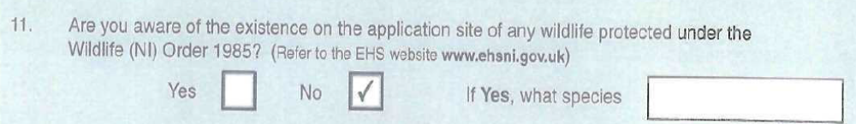

The Extended Phase 1 Survey and Assessment did note evidence of badger activity, therefore a more detailed and comprehensive survey for badgers should have been recommended in this report.

Disturbance to Protected Reptile Species: Viviparous Lizard Zootoca vivipara
The Extended Phase 1 Survey and Assessment of Ballinlea states on page 11 that ‘No habitat considered suitable for Common Lizard was present’. Viviparous or common Lizard Zootoca vivipara regularly breed within 1.25km of the proposed drilling site and in buildings similar in construction to those derelict buildings sited at 49 Ballinlea Road i.e. derelict stone buildings/walls. There are highly likely to be lizards in the derelict buildings at 49 Ballinlea Road area, but no complete EIA survey of the site has been undertaken by the proposed developers.

Disturbance to nesting birds.
Birds nesting in the area of the proposed drilling site at 49 Ballinlea Road include blackbird, chaffinch, goldfinch, house sparrow, jackdaw, robin, starling and wren. Both house sparrow and starling nest in the derelict farm buildings at the north east corner of the proposed site and any works carried out during the nesting season will have a detrimental effect on the breeding productivity of these species. It is an offence under the Wildlife and Natural Environment Act (Northern Ireland) 2011 to kill, injure or take any wild bird or to damage or destroy the nest of any wild bird while that nest is in use or being built or to take or destroy an egg of any wild bird.

Disturbance to Corncrake and incomplete survey of Corncrake activity.
The Corncrake is a schedule 1 species, which is red listed in the Irish Birds of Conservation Concern list. A Corncrake was recorded in the vicinity of the proposed development last year, a calling male. This is an indication that Corncrakes are now returning to the immediate area, after a long absence, but no complete EIA survey of the site has been undertaken by the proposed developers.

Disturbance to Otters in the tributaries of the River Bush.
Otters, a protected species, are known as seasonal visitors within the tributaries of the River Bush. The stream adjacent to the proposed development site is part of this river system. Traces of Otters have been recorded at local streams within 1km of the development area, but no complete survey of the site and the local stream has been undertaken by the proposed developers.

- Will Rathlin Energy be required to undertake a complete and comprehensive Environmental Impact Assessment before their application will be considered further?

Climate Change
The exploration phase cannot be treated separately from the production phase in relation to the shale gas industry’s impact on climate change, since both are part of the chain of causation. The Committee on Climate Change has recently written to the Energy Minister expressing the view that the exploitation of shale gas will undermine the UK’s ability to reach Carbon reduction targets and will therefore breach the Climate Change Act.

Risks to roads, landscape and geological stability

Impact of increased traffic on rural roads

According to Rathlin Energy Ltd’s supporting document, Proposed Borehole, 49 Ballinlea Road, Ballycastle: Transportation Statement, the proposed works will generate an additional 34 trips by HGV vehicles per day, which will means, based on figures provided in the document, that HGV traffic will be at 225% of the usual levels, a very significant increase for a small country road—and this is just for an exploratory well.

The company proposes that the site-related traffic will use the Ballinlea Road to access the main trunk roads at Ballymoney, a journey which includes travelling over the Dry Arch, a local landmark stone bridge that carries the Ballinlea Road (B147) over the Moyarget Road (B67). The company has not considered the impact of the proposed increase in both size and volume of HGV traffic on this important landmark, which was not built to support this kind of traffic.

A further concern is that the report only discusses mobilisation and drilling phases (Page 3) , when there is a third essential phase that will be unavoidable; demobilisation. What will the impact of the demobilisation phase be on the Ballinlea Road?

Impact of mass drilling (especially if fracking is allowed) on local geological stability

There are known fault lines along the Causeway Coast area. Running close to the proposed Ballinlea 2 site is the Lemnagh Fault. Slightly further away are the Portbraddon and Port More faults (see Appendix 2).

Serious consideration needs to be given to the impact of Rathlin Energy Ltd’s proposed development for the Rathlin Basin on the stability of the area, especially as it contains the UNESCO World Heritage Site, the Giant’s Causeway, which is visited by about 600,000 visitors per year.

The Dutch area of Groningen is increasingly suffering from earthquakes (about 1 per week) caused by onshore conventional gas drilling. 60% of 60,000 residents have reported damage to their homes and a recent small-scale tremor, of 3.0 on the Richter Scale, damaged a dyke 25km away, creating concerns about a potential disaster. Further evidence from the USA reported by the BBC indicates how pumping of drill fluids under pressure can result in localised earthquakes within known faults, in response to distant quakes.

As the research catches up with the impacts of the oil and gas industrial juggernaut, more evidence is emerging about the impact of injecting drill fluids deep into the earth either during drilling, fracking or waste ‘disposal’. Seismologists from the Columbia University and University of Oklahoma have just released a report connecting the injection of drilling fluids with increased numbers of earthquakes, and can see a direct correlation between the number of earthquakes and the amount of drill fluid injected. However, as yet, they cannot predict the magnitude of the earthquakes. They say the impact of injecting the fluid is that it fills, primes and lubricates fissures, cracks and faults, manmade or natural, so much so that a large earthquake elsewhere can trigger earthquakes in drill fluid areas which would not otherwise have occurred.

"Seismologists have known for some time that there are transient stresses from earthquakes that can potentially cause other faults to slip, causing an earthquake," Prof Davies told BBC News….. "But this paper is a very interesting contribution, as it proposes that mankind can artificially 'prime the faults' by injecting wastewater over long periods under the ground…… "Mankind is essentially lubricating the faults enough so that they are eventually triggered by a distant, natural earthquake. Think of a hovercraft - the air pumped into the base of the craft means that even small forces allow the heavy vehicle to move - the physics is the same."

Do we want to risk an earthquake damaging the Giant’s Causeway or the local Tourist infrastructure and homes? The implications of recent research suggests that these risks are real if we allow mass gas or oil extraction to proceed in this area.

- How will the potential impact of this proposed development on geological stability be assessed –particularly in light of this new research?

Risks to valuable, sustainable, local economy (agriculture and tourism)

The risks posed to tourism and agriculture, key areas of the local economy, are unacceptable. Rathlin Energy has publicly admitted that any potential jobs created by this project will be very limited in number and short-term in nature.

Effects on Tourism, Tourist Income & Related Jobs
The proposed temporary drilling works and multitude of ‘nodding donkeys’ or frackpads envisioned by the company for the long term, will cause long-term damage to two of the most important sectors of the local economy - tourism and agriculture.

In the Moyle district alone, tourism generates £27 million pounds per annum, which is 5% of the total for Northern Ireland. The Causeway Coast and Glens region is made up of 6 local authority areas – Ballymena, Ballymoney, Coleraine, Larne, Limavady and Moyle and accommodates about 24% of NI’s domestic and inbound visitation and spend; equally, the area accounts for over 42% of Northern Ireland’s tourism accommodation and 29% of its rooms and beds stock (latest available information from the NITB). The region hosts 2 of the top 10 visitor attractions in NI, (The Giants Causeway & the Carrick-a-rede Rope Bridge), and there are an estimated 5,682 direct and 18,392 indirect jobs dependent on tourism in the area.

High environmental standards are now core aspects of visitor expectations and not optional extras. These aspects can be the primary reason tourists have for visiting an area, and growth in tourism against competing destinations can only be sustained if the quality of the natural and built environment, which underpins the region’s appeal, is maintained. The clean, unspoilt and green image of the North Coast area, (which is almost entirely covered by the Rathlin Basin Petroleum Exploration Licence Area), is of paramount importance. The perception of this area as environmentally uncontaminated and non-industrial is key to its current success as a tourist destination. These green environmental credentials are too easily squandered or lost.

Many tourists directly enjoy the unspoilt local environment through house lets, cycle tours, walking tours, angling, water sports, wildlife observation, etc. These tourist activities underpin many small businesses within the Licence Area and this Oil & Gas Exploration and its subsequent extraction will only serve to threaten and damage this clean and green environmental image. As a direct result, tourist income will be adversely affected and this will have a knock-on effect on existing and predicted local jobs. Tourism performance and success in the Causeway Coast area significantly impacts on NI’s success as a whole.

Effects on Farming, Agriculture & Rural Income

This proposed exploration well at Ballinlea Site 2 poses a real risk of air, water and land contamination, as the cumulative effect of increasing well numbers increases the risks. Livestock suffer some of the same conditions as humans when exposed to toxic chemicals, as they affect the endocrine, respiratory and reproductive systems. Crops and livestock downstream of this proposed development will be at risk if water contamination occurs.

To approve this development would signal the progressive industrialisation of what is currently a rural landscape bordering on an area of Outstanding Natural Beauty and areas of Special Scientific Interest. The implications of any serious pollution event occurring in the future places farming in jeopardy and as such puts at risk the livelihood of many living and working in the rural economy in this region.

The 2012 farm census covering the Moyle district alone states that there are 38,043.6 hectares of land farmed giving direct employment to 2,748 people.

Even concerns over the pollution of air and water courses, as a result of drilling, poses a substantial threat to the domestic and export markets for local agricultural produce (as has happened to farmers in Australia and New Zealand), as the perceived health risks of consuming contaminated local produce drives consumers elsewhere.

This and future oil and gas exploration within the Licence Area, would threaten environmental purity, natural amenity and the natural landscape and will cause a detrimental effect on tourism and agriculture both of which are documented as major employers in the area.

Conclusion

I look forward to receiving a response to the issues and questions raised in this submission.

The proposed development is close to a designated Area of Outstanding Natural Beauty as well as areas of Special Scientific Interest (it is just 1km from Prolusk ASSI). Moreover, it must not be considered in isolation, but as one of a series of such developments across the Rathlin Basin. The cumulative impacts of drilling addition wells should be considered.

The following abstract comes from a journal article which should be required reading about the “Impacts of gas drilling on human and animal health”:

“Environmental concerns surrounding drilling for gas are intense due to
expansion of shale gas drilling operations. Controversy surrounding the
impact of drilling on air and water quality has pitted industry and lease -
holders against individuals and groups concerned with environmental
protection and public health. Because animals often are exposed continually
to air, soil, and groundwater and have more frequent reproductive cycles,
animals can be used as sentinels to monitor impacts to human health. This
study involved interviews with animal owners who live near gas drilling
operations. The findings illustrate which aspects of the drilling process may
lead to health problems and suggest modifications that would lessen but
not eliminate impacts. Complete evidence regarding health impacts of gas
drilling cannot be obtained due to incomplete testing and disclosure of
chemicals, and nondisclosure agreements. Without rigorous scientific studies,
the gas drilling boom sweeping the world will remain an uncontrolled health
experiment on an enormous scale.”

On the grounds outlined in this submission I would urge you to:
- reject this planning application, and
- ensure that any future application of this nature is required to include a full and comprehensive Environmental Impact Assessment, taking into account all aspects of the proposed development and operations.

APPENDIX 1
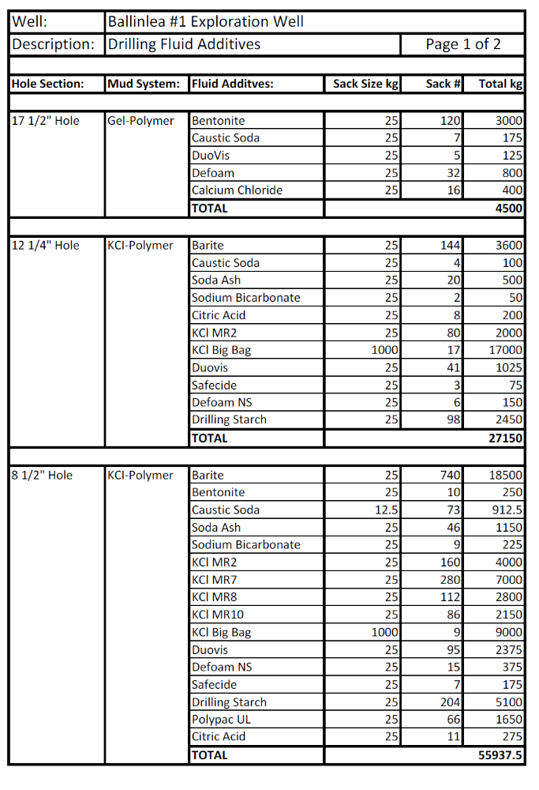
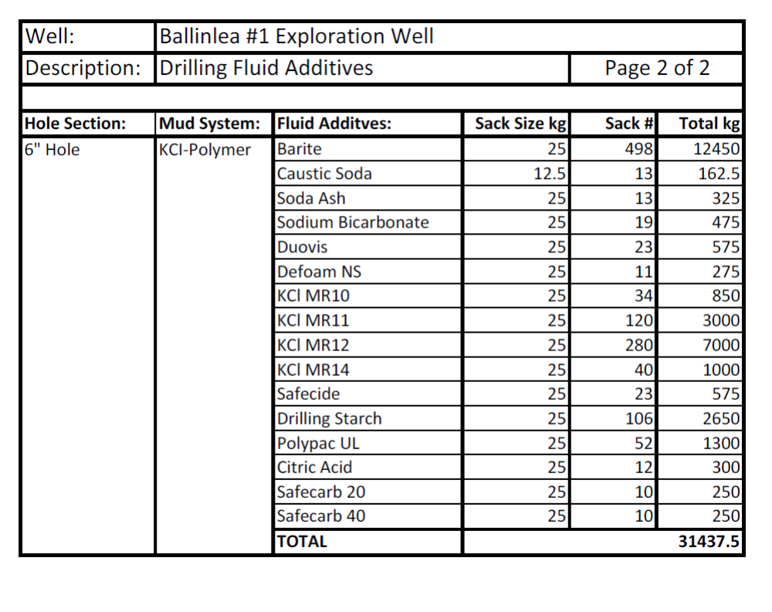

APPENDIX 2

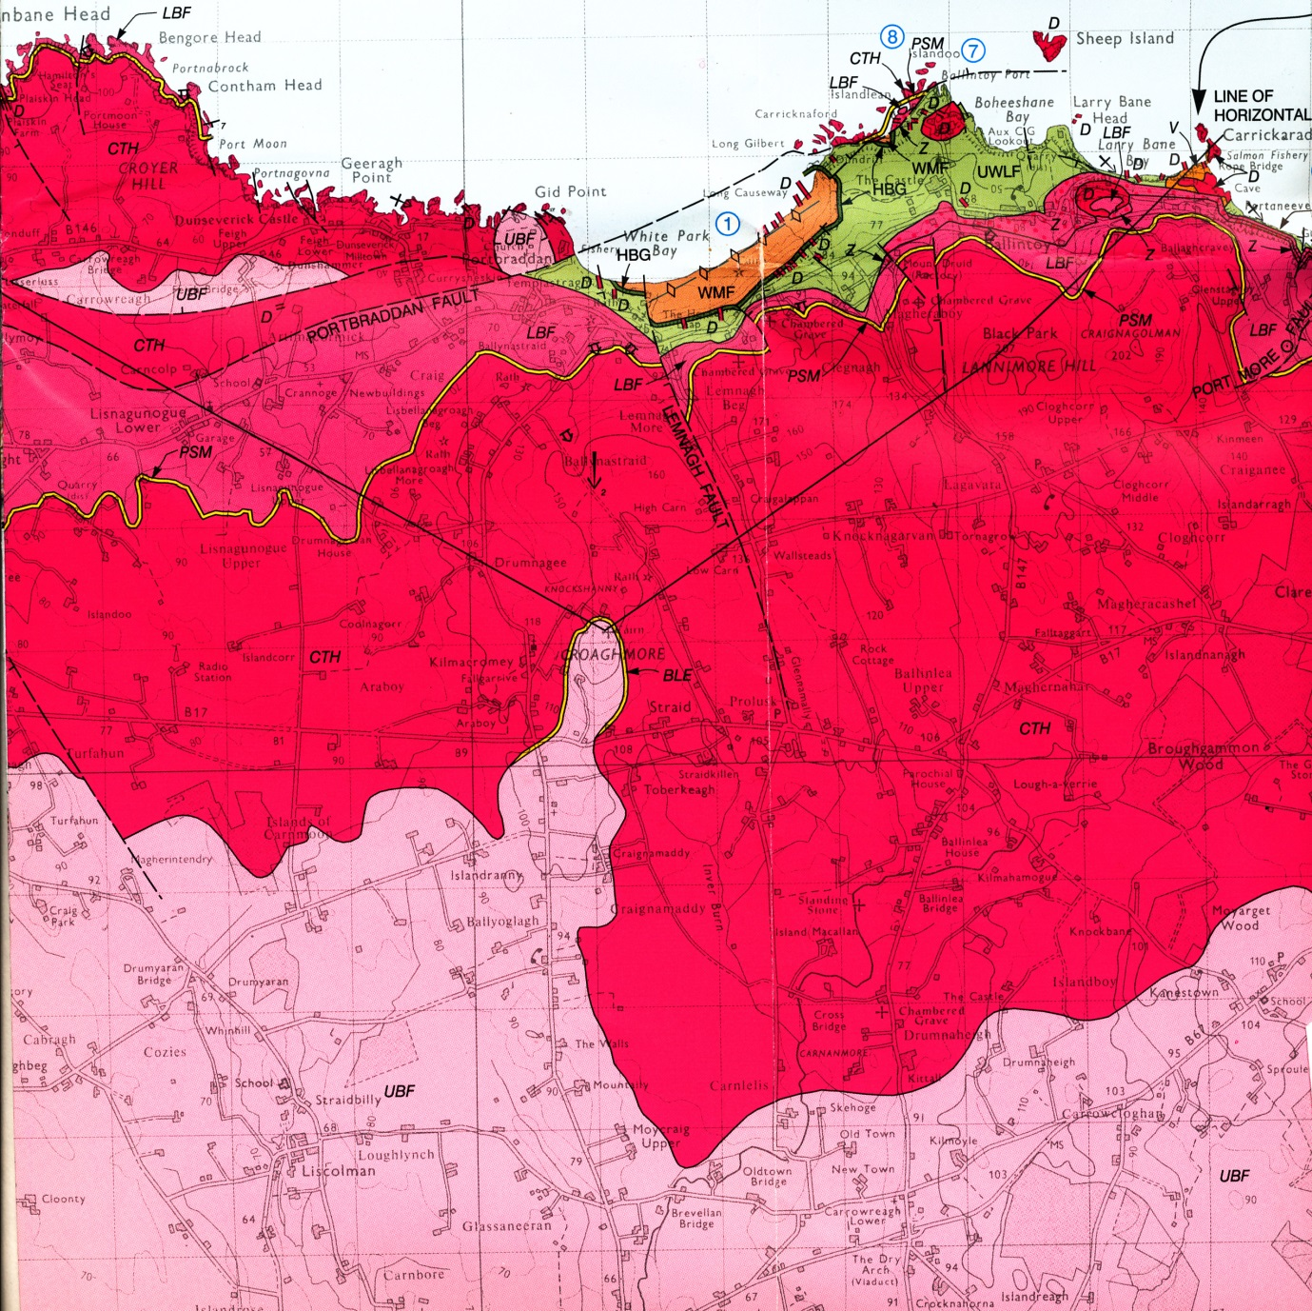

http://www.slb.com/~/media/Files/resources/oilfield_review/ors03/aut03/p62_76.ashx
http://www.pnas.org/content/early/2013/06/19/1221635110.full.pdf+html
http://www.endocrinedisruption.com/files/Multistatesummary1-27-11Final.pdf
http://www.timesunion.com/opinion/article/Fracking-is-hardly-leakproof-3646458.php
http://www.endocrinedisruption.com/files/Multistatesummary1-27-11Final.pdf
http://www.telegraph.co.uk/news/worldnews/europe/netherlands/10162343/Earthquakes-from-onshore-gas-drilling-threaten-a-disaster-warn-residents-of-Dutch-city.html
http://www.sciencemag.org/content/341/6142/164.abstract
http://www.bbc.co.uk/news/science-environment-23271168
http://www.nitb.com/ResearchIntelligence/TourismFactsandFigures/TourismPerformanceStatistics.aspx
http://www.nitb.com/ResearchIntelligence/TourismFactsandFigures/TourismPerformanceStatistics.aspx
http://www.abc.net.au/news/2013-06-21/fonterra-oil-drilling/4770874 http://www.radionz.co.nz/news/rural/138025/fonterra-to-stop-taking-milk-from-farms-with-oil-and-gas-waste http://www.beefcentral.com/p/news/article/1247
http://www.doeni.gov.uk/niea/protected_areas_home/aonb.htm
http://www.doeni.gov.uk/niea/prolusk_-_a_special_place.pdf
Bamberger, M., and Oswald, R., 2012, Impacts of Gas Drilling on Human and Animal Health, NEW SOLUTIONS, Vol. 22(1) 51-77 http://www.psehealthyenergy.org/data/Bamberger_Oswald_NS22_in_press.pdf

